**JMeter Performance Testing:**

Here you will see the process to perform JMeter Performance Testing in 5 steps:

1. Setting up Apache JMeter

* The first step is to go to the Apache JMeter folder
* Go inside the bin folder
* Select the JMeter .bat file
* Double click on this file

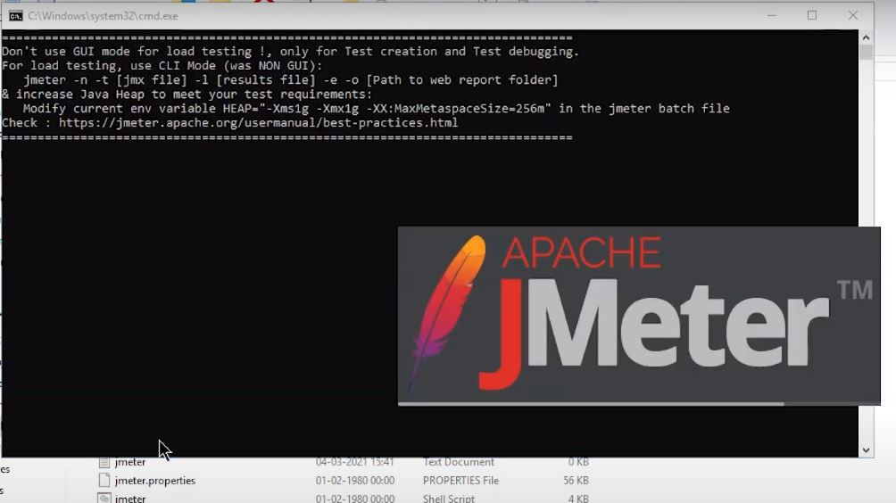

This might take a while, and then the JMeter window will open on the screen.

Here, the test plan is renamed as performance testing.

2. Adding a Thread Group

* Right-click on the Performance Testing
* Go to add, then go to Threads (Users) and select Thread Group

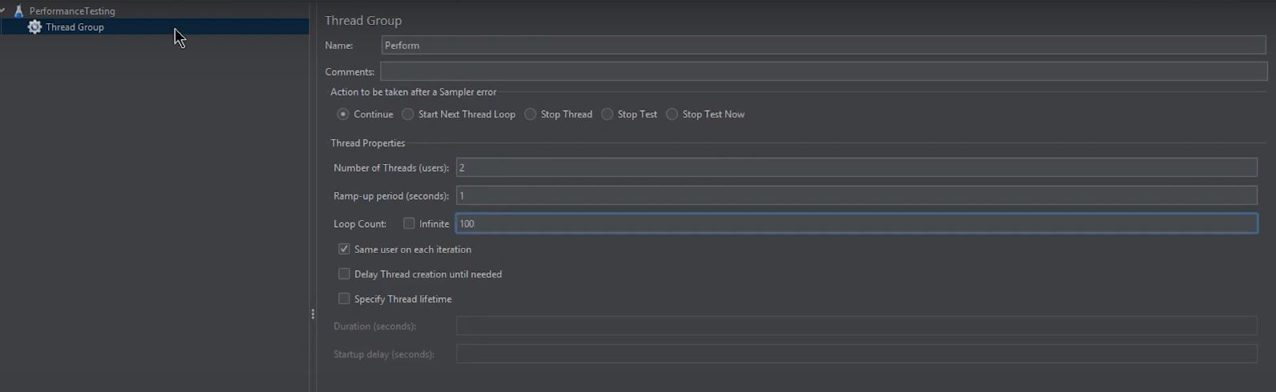

Here, the thread group can be understood as users, i.e., the number of users.

It has several options, like

* Action to be taken after there is an error: you can choose it the way you want
* Then, there is a “number of threads” where you can choose the number of users you want
* Then, there is a “ramp-up period in seconds” that states the time gap between the users' hits
* There is a “loop count” option where you can choose how many times the test will run for the number of users. You can also choose the test to run infinite times
* There is also a scheduler here to help you schedule the start time and the test’s end time
* For now, make the number of threads to be 2. And loop count to be 100.

3. Adding HTTP Request

* Right-click on the Thread group, go to add option and go to the sampler option
* In the menu that appears, select the HTTP request option

You can see a Server Name or IP box; it will give the server name or the IP in that.

This demo will use Simplilearn's website, here.

* Go to Simplilearn's website
* Copy the URL from here
* Come back to the JMeter window
* Paste the URL in the Server Name box

Don't give http or HTTPS since these are protocols that will come in the other box and that will be automatically taken in the http request case.

* In the path dialog box, leave a forward slash.

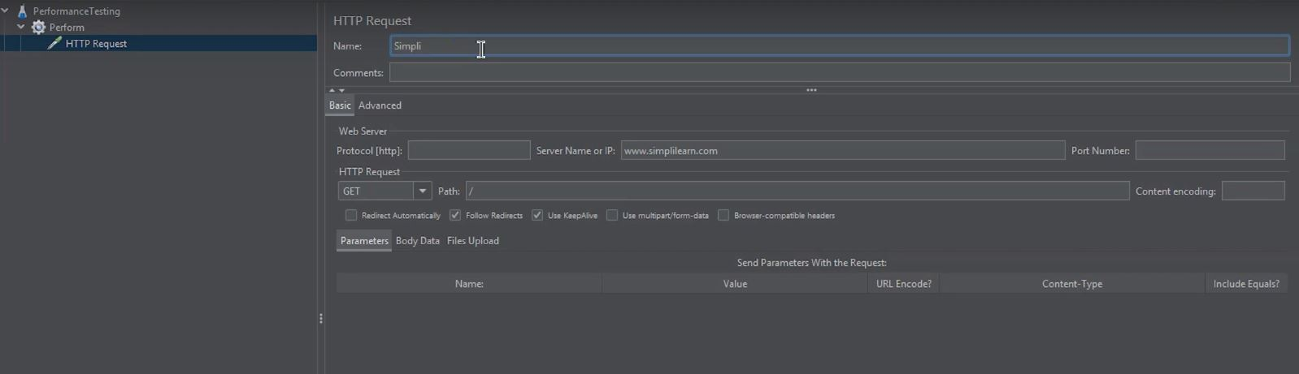

The forward slash is used since the aim is to access the route page.

* Here, this demo will rename this HTTP request as Simple.

Now, to get results, let's add listeners. Listeners are something that is used to provide the outputs of a load test. There are different types of listeners present in JMeter, and a good deal may be added using [plugins.](https://www.simplilearn.com/tutorials/jmeter-tutorial/jmeter-plugins)

4. Adding Listeners

You can use three different listeners here to have an idea about the representation that the JMeter provides

* Right-click on the Thread Group
* Go to Add, select the Listener option, and go for the view Results in Tree option

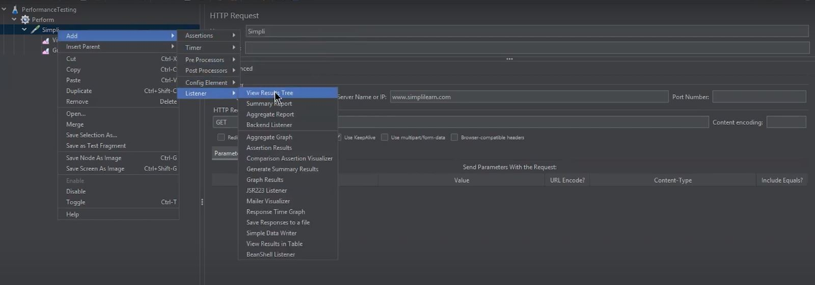

* Again, right-click on the listener option and choose graph results
* And for the third listener, right-click again and select the View Results in Table option

Now, it's time to run the test.

5. Running the Test

* Save this JMeter test

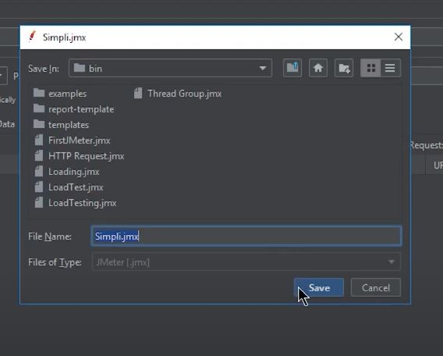

* Click the green button and run the test

Now when you visit the "View Results Tree," you can see the test running. Same with graph results. Then you can also see the time the test has been executing.

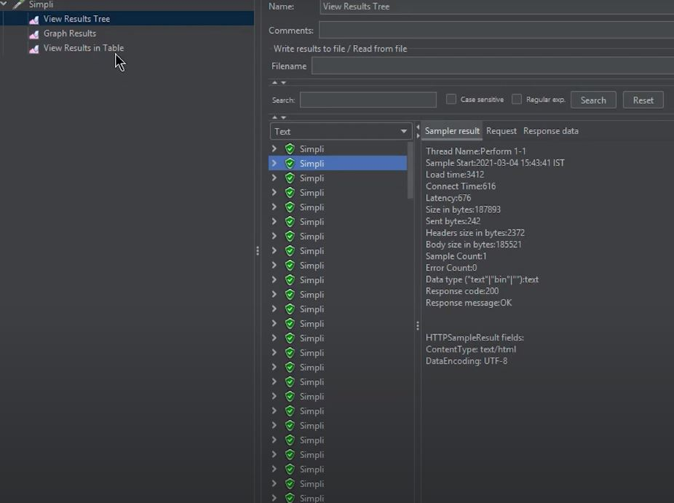

Since this demo had put two threads and a loop count of 100, the test will run for a while. When you check the "view results in table", you can see different performance testing metrics on the screen. You can see the thread name, label, Sample Time per second, Bytes, Sort Bytes, and the latency.

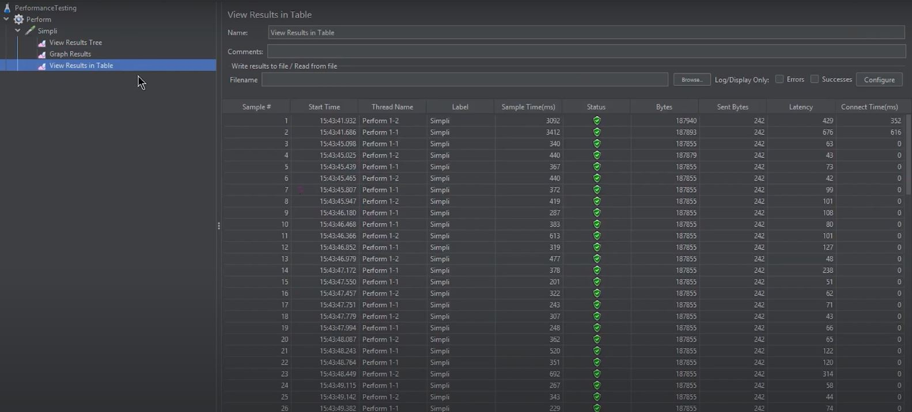

Then, in the tree option, you can see several performance testing metrics clicking on any of the tests. And in the graph results, you can see the graph coming on the screen now, representing the tests taking place concerning the IP address, thread, and loop counts.

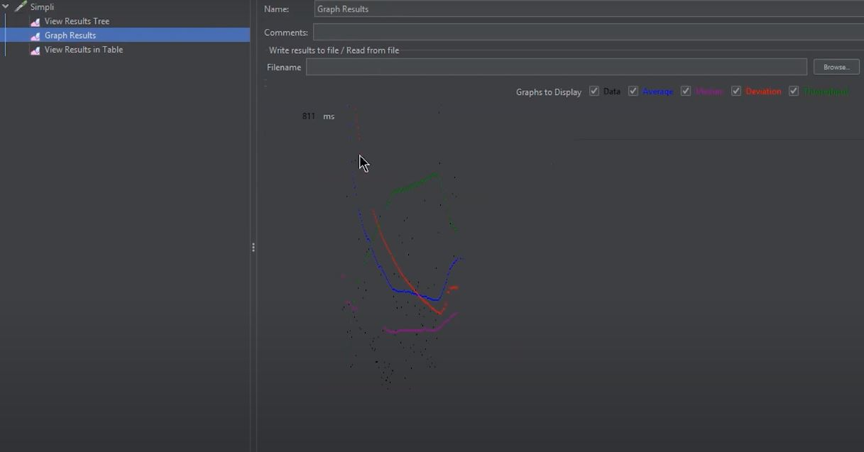

So, what JMeter exactly does is, creates a request and sends it to the server. Once it receives the server's response, it collects them and visualizes those details in a chart or graph. After that, it processes the server's response, and finally, it generates the test results in several formats such as TXT, XML, JSON so that the tester can analyze data.

Conclusion

By now, you would have learned everything about JMeter Performance Testing. You began with learning the basics of Performance Testing and checked its relevance in today's scenario. Then you understood the process of performing Performance Testing and came across different Performance Testing metrics. After that, you saw different tools that can be used to perform performance testing, and one such tool is the JMeter. Here, you learned about JMeter and its needs. Finally, you understood the entire process of Performance Testing in JMeter with a hands-on demo.

If you have any questions for us, do let us know in the comment section below. We will have our experts answer it for you right away.